1. **Main Benefits of SharePoint 2013.**
   1. Share - storing and sharing documents, contacts, and tasks; organizing meetings; managing business processes. Share information to social network, like Facebook, twitter.
   2. Organize - help you manage tasks, as well as their status and due dates. Keep team connected through shared information.
   3. Discover – search engine.
   4. Build – App and Cloud.
   5. Manage – Office 365
2. **Logical and physical architecture**

**Front-end web servers** - These servers publish websites, often called web applications.

**Application servers** - These servers host back-end services, such as Search services, the User Profile service, Excel Services, and so forth.

**Database servers** - These servers store configuration and content data for the entire SharePoint farm.

1. **Service Application**

Service applications are software service run in a SharePoint farm. One service application can publish to multiple servers in a farm. Service applications are intended for sharing resources and capabilities across multiple sites and servers in the same farm, or even across farms.

1. **Feature receivers**

• Feature activation

• Feature deactivating

• Feature installation

• Feature uninstalling

• Feature upgrading

1. **LINQ (Language-Integrated Query)**

LINQ is a programming model that introduces queries as a first-class concept into any Microsoft .NET language.

LINQ makes it easier to access all these various kinds of data (such as an array, an object graph, an XML document, a database, a text file, a registry key, an e-mail message, Simple Object Access Protocol (SOAP) message content, a Microsoft Office Excel file), providing a unified programming model

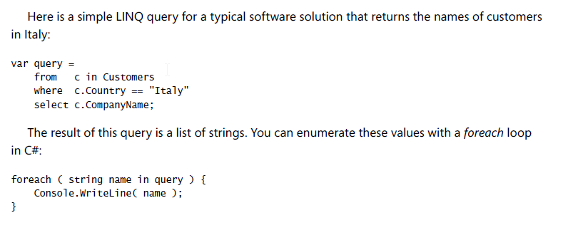

1. **Server-side technologies**

Server Object Model

LINQ

1. **Client-side technologies**

Client Object Model

The REST API (Representational State Transfer)

1. **The Rest API (Representational State Transfer)**

Use unique URL to query, update, delete the resource of SharePoint server.

Demo:

http://devbook.sp2013.local/_vti_bin/ListData.svc/DevLeapContacts(1)

1. **SharePoint APP**
   1. **App Type**

Full Page APP

App Parts

UI command extension

* 1. **Hosting Models**

**SharePoint-hosted** – On-premised host. You can take advantage of all the features of SharePoint, such

as lists, Web Parts, pages, workflows, and so on.

**Auto hosted Apps** - following this model are hosted on Microsoft Windows Azure, which can access a Microsoft SQL Azure database for managing data, too.

**Provider-hosted** - this model are almost the same as auto hosted apps. The only difference is that a provider-hosted app has to be deployed on your own hosting environment and does not necessarily use the Windows Azure environment.

Regardless of the hosting model and configuration, every SharePoint app is mainly a web application that interacts with SharePoint using the Client Object Model and the new REST API introduced with SharePoint 2013 (which is covered in Chapter 9, “The new SharePoint REST API”). One key feature of SharePoint apps is that they can be developed with any programming language or technology, as long as you host them outside SharePoint (that is, using an auto hosted or provider-hosted model). In fact, you can create a SharePoint app using PHP, Java, or any other technology capable of communicating with SharePoint via the new REST API and the OAuth protocol.

* 1. **You can convert a site to SharePoint APP**

P287

* 1. **You can use DB of Azure**

P289

1. **REST API schema**

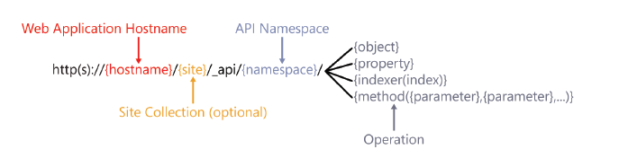

1. **Remote event receivers**

The architecture of remote event receivers uses SOAP as the protocol for communicating across the wire, because it is the most open, standard protocol for implementing cross-platform dialogs.

* 1. **Scopes and types of receivers**

Scope: Single list item, List, Website, APP

1. **Web Parts**
   1. **Classic Web Parts**
   2. **Visual Web Parts**
2. **Customizing the UI**
   1. **Custom Actions**

**■CustomAction -** Creates a new custom action to define a new control on a ribbon, a new menu item on a standard menu, or a new link on a settings page

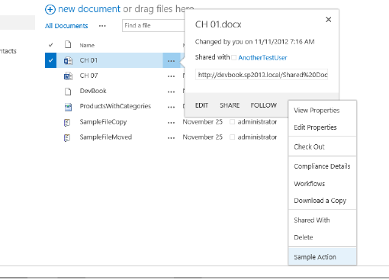

**■CustomActionGroup -** Creates a new group of custom actions for better usability from the perspective of the end user

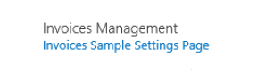

**■HideCustomAction -** Hides an existing custom action defined by another custom action or implemented by default in SharePoint

**■Server-side custom actions**

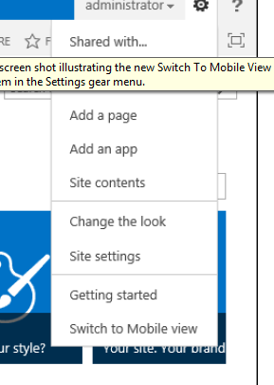

* 1. **Custom Ribbons**

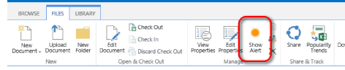

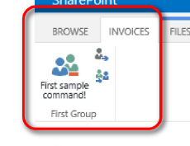

* 1. **Custom Content**

**Images and generic content.**

**Application pages.**

**Content pages, web part pages and galleries.**

* 1. **Status bar and notification**
  2. **Dialog Framwork**

1. **Web Templates**

**The Core Techniques**

* 1. **Site Definitions**

A site definition is a site model defined on the file system and stored in the folder SharePoint15_Root\TEMPLATE\SiteTemplates of every front-end server. Saving files on the file system is an ancient habit that requires direct access to the servers in your server farm. Thus, it is not suitable for Microsoft Office 365 or SharePoint Online.

* 1. **Feature Stapling**

Feature stapling is a technique that enables you to customize existing site definitions by adding custom features to extend the site definition.

* 1. **Site Templates**

A site template is an exported snapshot of an already existing site instance, with or without its content. You can use a site template, which is basically just a WSP package, to replicate a site instance from one environment to another, as long as the base site definition is available on the target environment, too. In addition, you can import site templates into Microsoft Visual Studio 2012 to create custom template projects. To save a site template from an already existing site instance, simply click Save Site As Template in the Site Actions menu group on the Site Settings page. The one exception, however, is that a site template cannot be created from a site in which publishing features are enabled, so it’s only usable in team and collaboration sites.

* 1. **Web Templates**

A web template is a specific Web Template feature that you can create using Microsoft Visual Studio 2012 and provision using a sandboxed solution. A web template enables you to define a custom site model for future reuse. You can deploy web templates at the site collection level, through a sandboxed solution, or at the farm level using a full trust WSP solution package. Because web templates can use a sandboxed solution for deployment, you can use them against Office 365 and SharePoint Online, too.

1. **Business Connectivity Services**

Business Connectivity Services (BCS) is a fundamental service application of Microsoft SharePoint 2013. It provides capabilities to read and write data from external systems, such as line-of-business (LOB) applications, web services, databases, and any other external sources that offer a suitable connector.

Read at

is a fundamental service application of